Yu.Senichev
Orbit lengthening and chromaticity
- Three components of deviation affected on orbit lengthening
Let us write the motion equation in the horizontal and vertical planes 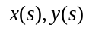 with the longitudinal coordinate:
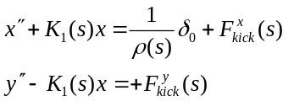, (1)
where 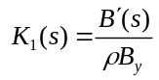 is quadrupole strength with gradient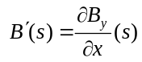, 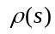 is the orbit curvature,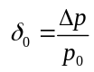 momentum spread,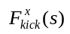 and 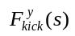 are external nonlinear forces of an arbitrary order. In particular, for the sextupole field 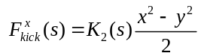 and 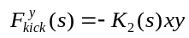, where 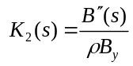 with the gradient 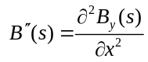. Here we enter the designation of «kick»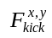 , since further we will consider the right side of equation (1) as a weak perturbation of free oscillation of particle concentrated on a short period with fixed deviation from axis.
The total displacement of non-referent particle relative of the referent is defined through three components:
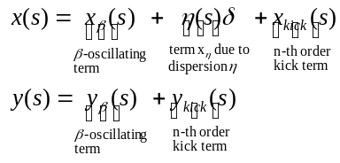 (2)
- «-oscillating» term
We suppose that the dispersion in the vertical plane is absent. Now let's define each term individually. We start with the first-oscillating term 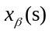. It can be determined solving the homogeneous Hill equation describing the free oscillation in zero-dispersion optics:
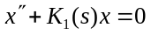, (2a)
and using Floquet theorem:
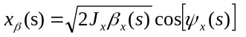, (3)
where 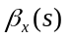is the beta function, 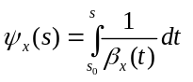is Floque phase, 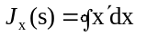is an action integral. Instead of an action integral an emittance is often used 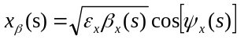. For the vertical plane it will be similar
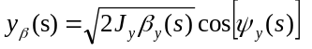. (3a)

- «Dispersion» term
Now let's define a term arising due to the dispersion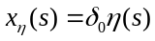 in horizontal plane, where the periodical solution of dispersion 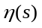 is determined from the equation (without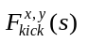):
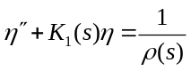 (4)
The periodical solution of (4) is seek using the method of constants variation:
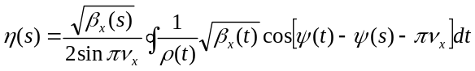, (5)
Now multiplying (5) by the momentum spread we obtain the seeking second term of (2):
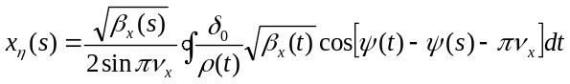 (5)
- External «kick» term
Now we suppose that in an arbitrary point of orbit 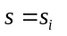 we have the kick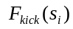. Let us again to use the method of variation of constants. Integrating along the element length 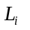 in an approach of a constant kick value and summing over all elements we have the expression for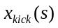:
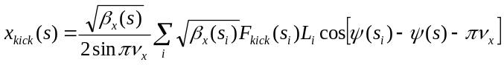 (6)
- Orbit lengthening
Now we have all the necessary expressions to determine the orbit lengthening. In common view we have:
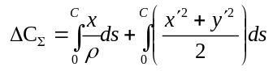, (7)
where 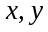are total deviation for both coordinates.
- Non-linear contribution
Let's start with the non-linear contribution 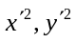 entering into the second integral of (7).
Using (3) and the ratio for Twiss parameters 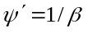and 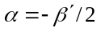we have for the homogeneous equation (2a):
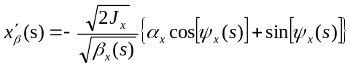 (8)
Since the average value over whole ring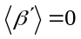, hence 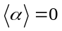and 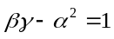 then (8) is:
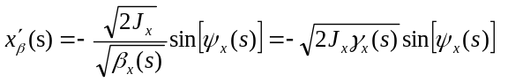 (9)
For the vertical plane we have the same:
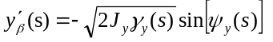 (10)
Substituting (10, 9) in (7) we have:
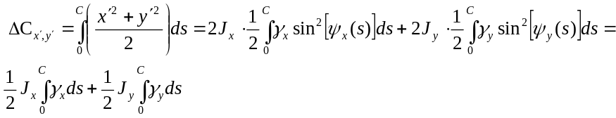 (11)
- Linear contribution
Contribution of the-oscillating term in first part of (7) will be zero. Therefore first part of (7) is defined only by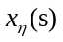
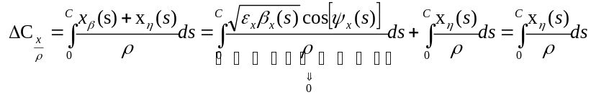, (12)
and
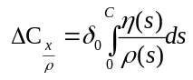 (13)
Since the integral in (13) is the momentum compaction factor definition then
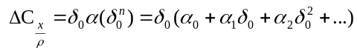 (14)
Obviously, the term (13) makes a significant contribution to the lengthening of orbit due to linear term 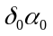 of momentum compaction (14). To compensate the effect of linear dependence of the orbit lengthening on momentum spread the RF field is used for mixing particles with different deviation from equilibrium momentum that is by 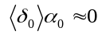. However it does not allow getting 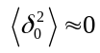. Therefore, in the case of a significant contribution of this term to the lengthening of the orbit it will be necessary to adjust the optics using sextupoles up to 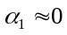.
- External kick
Using expression (6) and substituting it in 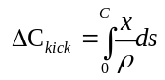 we have the orbit lengthening due to non-linear external kick:
(15)
Thus, the orbit lengthening due to external kick is equal to the sum of product of the normalized kick and the dispersion function in the place of kick. Further this formula will be used for the non-linear kick of sextupoles.
Sextupole correction
Now let us consider the sextupole correction. In that case the equation (1) takes a view:
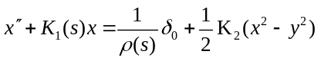, (16)
Many authors simplify the equation solution (16) by replacing the nonlinear term 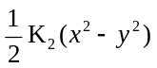 on a permanent impact along i-th sextupole with a force
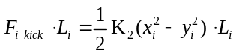 (17)
proportional to the square of the particle deviation from the axis that is by replacing the nonlinear term to permanent one. Substituting (3,3a) in (17) we have:
(18)
Following (15) we can write the expression for the orbit lengthening due to sextupoles:
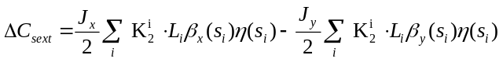 (19)
or passing to integration in (19) we have the total orbit lengthening together with (11) and (14):
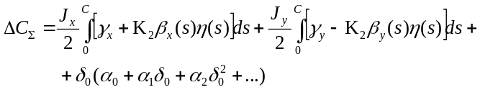 (20)
Chromaticity and orbit lengthening
The chromaticity in both planes is defined by known formula:
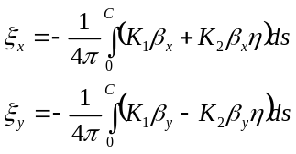 (21)
Simultaneously from Twiss relations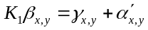, that is
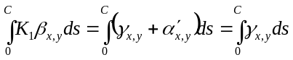, (22)
since 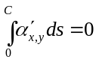. Finally we have the expression for chromaticity:
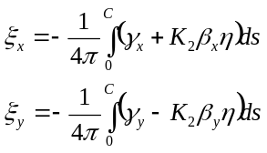 (23)
Comparing (20) with (23) we can submit the orbit lengthening through the chromaticity:
(24)
Conclusion
So we can say that in case of short length of sextupoles the betatron oscillations give a zero contribution to the orbit lengthening at the total chromaticity equal zero.

